Case Study: Enhancing Efficiency and Security at DLA Investments Granite Mine
Background
DLA Investments Granite Mine, a premier granite extraction operation in South Africa, is committed to delivering high-quality stone to both local and international markets. To enhance operational efficiency and security, the mine sought to modernize its surveillance and monitoring systems while reducing dependency on traditional security measures.
Challenges
As a high-value quarrying site, DLA Investments faced several critical challenges:
- Security Risks: Theft of valuable granite slabs and unauthorized access to restricted areas.
- Remote Monitoring Limitations: Difficulty in overseeing vast mining areas efficiently.
- Infrastructure Constraints: Limited access to stable power and internet connectivity in certain sections of the mine.
- High Security Costs: Reliance on physical security personnel resulted in rising operational expenses.
Solution Implementation
Under the leadership of Johan, the Mine Manager, DLA Investments Granite Mine deployed a cutting-edge solution centered around:
- High-Definition AI Cameras
  - Strategically placed cameras provide real-time surveillance of critical areas.
  - AI-powered analytics detect unauthorized movement and send instant alerts.
  - Remote monitoring capabilities allow management to oversee operations from anywhere.
- Wi-Fi and Internet Connectivity
  - A reliable Wi-Fi network was established to support seamless video streaming and communication.
  - Internet-based remote access enables managers and security teams to monitor footage in real time from mobile devices and control centers.
- Solar-Powered Infrastructure
  - Solar panels power the surveillance system, ensuring uninterrupted operation even in off-grid areas.
  - Reduces reliance on traditional electricity, cutting costs and improving sustainability.
  - 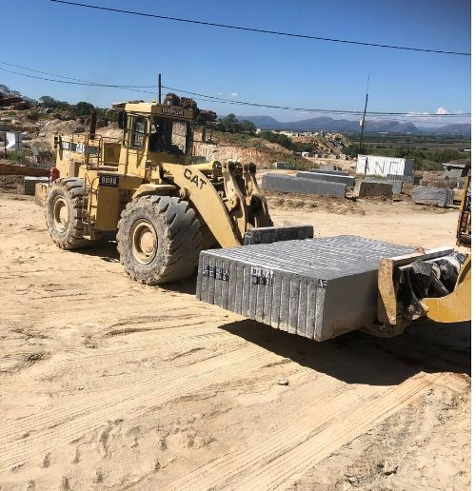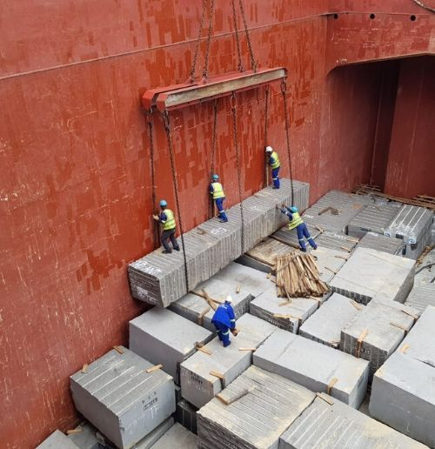

Results & Impact
Following the implementation of these solutions, DLA Investments achieved:
- Significant Reduction in Security Incidents: Theft and unauthorized access decreased by 40%.
- 24/7 Monitoring Capability: The AI-driven camera system ensures round-the-clock surveillance with instant alerts.
- Enhanced Operational Oversight: Improved visibility across the mine enhances workflow efficiency and worker safety.
- Cost Savings Through Workforce Optimization:
  - Reduced Manpower Costs: The deployment of AI-driven cameras has allowed for a significant reduction in on-site security personnel, lowering operational expenses.
  - Improved Efficiency: Fewer security guards are needed, as monitoring can now be conducted remotely via the internet.
  - Long-Term Sustainability: Solar-powered surveillance eliminates electricity costs associated with traditional security systems.
Conclusion
By leveraging AI-driven cameras, Wi-Fi connectivity, and solar power, DLA Investments Granite Mine has successfully enhanced security, operational efficiency, and sustainability. Under Johan’s leadership, the mine has embraced a technology-first approach, setting a new standard in the industry for modernized surveillance and monitoring solutions.
This transformation not only improves safety and productivity but also ensures long-term cost savings by reducing reliance on physical security personnel, making DLA Investments a leader in smart mining security.
